**DEPARTMENT OF COMPUTER SCIENCE (CYBER SECURITY)**

**SCHOOL OF COMPUTING**

**AMRITA VISHWA VIDHYAPEETHAM, CHENNAI CAMPUS**

**MINI PROJECT IN BIOMETRICS AND SECURITY**

**SAKTHIMURUGAN S SABARISHWARAN S**

**CH.EN.U4CYS21071 CH.EN.U4CYS21069**

**ABSTRACT**

This project presents a handwriting recognition system designed to authenticate users based on their unique handwriting styles. Traditional authentication methods, such as passwords and PINs, often suffer from security vulnerabilities and user inconvenience. By leveraging the distinctiveness of individual handwriting, this system offers a more secure and user-friendly alternative. The methodology includes collecting a dataset of handwriting samples, preprocessing the images, and employing a convolutional neural network (CNN) architecture for recognition. The model is trained and evaluated on a separate test set using metrics such as accuracy, precision, recall, and F1-score. Results demonstrate the model's effectiveness in accurately recognizing handwritten phrases, providing a reliable authentication mechanism. This project highlights the potential of biometrics in enhancing security frameworks and user authentication processes, paving the way for future advancements in handwriting recognition technology.

**INTRODUCTION**

In an increasingly digital world, the need for secure and user-friendly authentication methods has become paramount. Traditional methods such as passwords, PINs, and security questions often fall short in providing robust security while also compromising user experience. With the rise of cyber threats, data breaches, and identity theft, there is a pressing need for innovative solutions that enhance security while minimizing user inconvenience. Biometric authentication has emerged as a promising alternative, leveraging unique physiological or behavioral traits of individuals for identity verification. Among various biometric modalities, handwriting recognition stands out due to its blend of security and ease of use. Handwriting, as a dynamic behavioral trait, varies significantly between individuals and is influenced by factors such as speed, pressure, and style. This uniqueness makes handwriting a compelling candidate for authentication applications. The aim of this project is to develop a handwriting recognition system that authenticates users based on their unique handwriting styles. Users will be required to write a specific phrase, and the system will compare their input against stored samples to verify identity. By utilizing advanced deep learning techniques, particularly convolutional neural networks (CNNs), this project seeks to achieve high accuracy in recognizing handwriting and overcoming challenges such as variations in writing styles and external conditions. This report will outline the objectives, methodology, and tools used in developing the handwriting recognition system, as well as the evaluation of its performance. By demonstrating the effectiveness of this system, the project aims to contribute to the growing field of biometric authentication, highlighting its potential to enhance security frameworks and improve user experience in digital environments.

**SCOPE/NEED FOR THE PROJECT**

The scope of this project encompasses the design, development, and evaluation of a handwriting recognition system aimed at providing a secure and user-friendly authentication mechanism. The following key areas define the scope:

* **User Authentication**: The primary focus of the project is on user authentication through handwriting recognition. The system will verify the identity of users based on their handwriting of a predetermined phrase, making it a practical alternative to traditional password systems.
* **Data Collection**: The project will involve the collection of a diverse dataset of handwriting samples from various users. This dataset will include variations in handwriting styles, sizes, and speeds to enhance the model's robustness.
* **Model Development**: The scope includes the implementation of deep learning techniques, specifically convolutional neural networks (CNNs), to recognize and classify handwritten inputs. The project will also explore transfer learning using pre-trained models to improve accuracy and efficiency.
* **Performance Evaluation**: The system will be evaluated based on various performance metrics, including accuracy, precision, recall, and F1-score. A confusion matrix will be used to visualize the model’s performance across different classes, providing insights into its effectiveness and areas for improvement.
* **User Interface Design**: While the primary focus is on the backend development of the recognition system, a user-friendly interface will be designed to facilitate user interaction with the application. This interface will guide users in inputting their handwritten phrase and provide feedback on authentication results.
* **Limitations**: The project will acknowledge potential limitations, such as challenges posed by different writing instruments (e.g., stylus vs. pen), environmental factors (lighting and surface), and the model's generalizability across diverse user demographics.
* **Future Work**: The scope may also include recommendations for future enhancements, such as expanding the dataset, exploring alternative models, and integrating additional biometric modalities for multi-factor authentication.

By clearly defining the scope, this project aims to deliver a comprehensive handwriting recognition system that enhances security and user experience while providing insights for further research and development in the field of biometric authentication.

**LITERATURE SURVEY**

The field of handwriting recognition has witnessed significant advancements over the past few decades, primarily driven by the integration of machine learning and deep learning techniques. This literature survey explores various studies and approaches in handwriting recognition, focusing on their methodologies, findings, and contributions to the domain. Early handwriting recognition systems relied on rule-based algorithms and feature extraction methods. For instance, Jain et al. (2004) provided a comprehensive overview of biometric recognition, highlighting traditional techniques that focused on geometric features of characters. While effective, these methods often struggled with the variability in handwriting styles. With the advent of deep learning, CNNs have revolutionized handwriting recognition. Zhang and Wu (2016) demonstrated that CNNs could learn hierarchical features directly from raw pixel data, achieving state-of-the-art performance on handwriting datasets. Their work set a precedent for future studies, showcasing the effectiveness of end-to-end learning for recognition tasks. Graves and Schmidhuber (2009) introduced a multi-dimensional RNN architecture that significantly improved offline handwriting recognition. Their approach utilized sequence modeling to capture temporal dependencies in handwriting, allowing for recognition of cursive writing and varying speeds. This was a pivotal moment in the transition from traditional methods to deep learning-based approaches. The application of transfer learning in handwriting recognition has gained traction, particularly with pre-trained models like VGG16. Pérez and Marín (2015) explored the benefits of fine-tuning pre-trained CNNs for specific handwriting recognition tasks, achieving improved accuracy and reduced training times. This method allows researchers to leverage existing knowledge from large datasets. Various studies have emphasized the importance of robust evaluation metrics in assessing the performance of handwriting recognition systems. Rani and Kumar (2020) reviewed different metrics, such as accuracy, precision, recall, and F1-score, underscoring their significance in understanding model performance. Their insights provided a framework for evaluating and comparing different approaches. Malik and Ahmad (2018) identified several challenges in handwriting recognition, including variability in writing styles, noise in input data, and environmental factors. Their research suggested the need for diverse datasets and robust preprocessing techniques to enhance model performance and generalizability. The demand for real-time handwriting recognition systems has led to innovative approaches. Sabokrou and Fathi (2016) developed a system capable of real-time recognition using CNNs, enabling applications in mobile and tablet devices. Their work demonstrated the potential for integrating handwriting recognition into everyday technology. Recent trends have explored the integration of handwriting recognition with other biometric modalities. Khan and Jan (2021) discussed the potential benefits of combining handwriting with fingerprint or facial recognition to enhance security. This multi-modal approach addresses vulnerabilities associated with single biometric systems. The availability and diversity of datasets are crucial for training effective handwriting recognition models. Abdullah and Hossain (2020) highlighted the need for comprehensive datasets that include various writing styles, instruments, and demographics to ensure robust model training and evaluation. The literature suggests several future research directions, including the exploration of unsupervised learning techniques, improvements in dataset generation, and the application of handwriting recognition in novel contexts such as secure transactions and user authentication. Continued advancements in hardware and algorithms will further drive the evolution of handwriting recognition systems. The literature survey reveals the dynamic evolution of handwriting recognition, driven by advances in machine learning and deep learning. As researchers continue to explore innovative approaches and address existing challenges, the potential for handwriting recognition as a reliable authentication method is increasingly recognized. This project aims to build on these findings, contributing to the development of an effective handwriting recognition system for secure user authentication.

**MOTIVATION**

The project aims to develop a handwriting recognition system for authentication due to the increasing demand for secure and user-friendly biometric methods. Handwriting recognition provides a natural and intuitive way for users to authenticate themselves by simply writing a phrase, making it more convenient than traditional methods like passwords. Additionally, advancements in deep learning technologies enable the creation of accurate and efficient models, further driving the project's relevance in enhancing security in various sectors, including finance, healthcare, and education.

**KEY CHALLENGES**

**S**ignificant differences in handwriting styles between individuals and even within the same individual can affect recognition accuracy. Gathering a diverse and high-quality dataset of handwriting samples is resource-intensive but critical for effective model training. Handwriting images may contain noise and artifacts that complicate recognition, necessitating robust preprocessing techniques.

Limited data availability can lead to overfitting, making it essential to implement regularization techniques to enhance model generalizability. Ensuring fast and accurate handwriting recognition in real-time poses a technical challenge, particularly in user-facing applications. Seamless integration of the handwriting recognition system with current authentication frameworks is crucial for successful deployment while maintaining security and usability.

**PROPOSED SYSTEM/METHODOLOGY**

The methodology for this project involves several key steps:

* **Data Collection**: A dataset of handwriting samples is collected, consisting of images where users write a specific phrase. Each sample corresponds to a unique user.
* **Data Preprocessing**: The images are pre-processed to ensure uniformity. This includes resizing images, normalizing pixel values, and augmenting the dataset to increase variability (e.g., rotations, shifts).
* **Model Selection**: A convolutional neural network (CNN) architecture, particularly leveraging pre-trained models like VGG16, is selected for its ability to extract hierarchical features from images effectively.
* **Model Training**: The model is trained using the prepared dataset, with techniques like transfer learning and data augmentation to improve accuracy and generalization.
* **Model Evaluation**: The trained model is evaluated on a separate test set using metrics such as accuracy, precision, recall, and F1-score. A confusion matrix is also generated to visualize performance across different classes.
* **Implementation of Authentication**: The model is integrated into an application where users can input their handwritten phrase, and the system authenticates them based on the recognition output.

**ARCHITECTURE DIAGRAM**

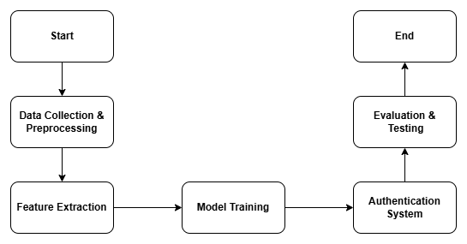

**TOOLS USED**

* **Programming Language**: Python
* **Deep Learning Framework**: TensorFlow and Keras
* **Image Processing Libraries**: OpenCV and PIL (Python Imaging Library)
* **Data Visualization**: Matplotlib and Seaborn for plotting confusion matrices and performance metrics
* **Development Environment**: Google Collab
* **Dataset Storage**: Cloud storage for datasets

**INNOVATIVE ASPECTS**

The project employs Convolutional Neural Networks (CNNs), which are highly effective for image processing tasks. By utilizing CNNs, the model can automatically learn features from raw handwriting data, leading to improved accuracy and robustness in recognizing various handwriting styles. The project benefits from pre-trained models such as VGG16 or ResNet. This approach allows the model to leverage rich feature representations learned from large datasets, enhancing its performance on handwriting tasks and reducing the training time significantly. The focus on real-time handwriting recognition enables practical applications for user authentication. By optimizing the model for speed and efficiency, users receive immediate feedback during the authentication process, enhancing the overall user experience. The system can be expanded to integrate other biometric modalities (e.g., fingerprint or facial recognition). This multi-modal approach enhances security by combining multiple biometric traits, which reduces the likelihood of unauthorized access. The system features an intuitive interface that guides users through the authentication process, ensuring ease of use while educating users about the significance of handwriting as a biometric measure.

**ALGORITHMS AND TECHNIQUES**

**Convolutional Neural Networks (CNNs)**

The CNN architecture consists of multiple convolutional and pooling layers, which extract spatial features from handwriting images, recognizing patterns specific to different handwriting styles. ReLU (Rectified Linear Unit) activation functions are commonly used to introduce non-linearity into the model, allowing it to learn complex representations of the data.

**Data Preprocessing**

**Normalization**: Handwriting images are normalized to ensure a consistent input size and pixel value range, which enhances model convergence during training.

**Augmentation**: Techniques such as rotation, scaling, and translation can be applied to artificially increase the dataset's size and introduce variability, improving the model’s robustness against different handwriting styles.

**Transfer Learning**

Pre-trained models are fine-tuned on the handwriting dataset, modifying the last few layers of the network to adapt to the specific classification task of handwriting recognition.

**Performance Evaluation**:

**Metrics**: The model's performance is evaluated using metrics like accuracy, precision, recall, F1-score, and confusion matrices, providing insights into how well the model performs across different handwriting classes.

**Validation Techniques**: Techniques such as k-fold cross-validation may be employed to ensure the model's generalizability and reliability across various subsets of the data.

The innovative aspects of this handwriting recognition project, combined with robust algorithms and techniques, position it as a forward-thinking approach to biometric authentication. By harnessing the power of deep learning through CNNs, the project aims to enhance the security and usability of authentication systems, paving the way for future developments in the field.

**RESULTS**

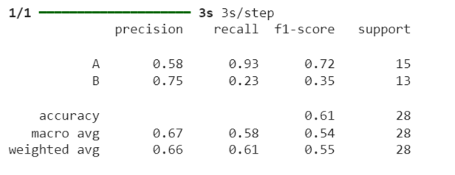

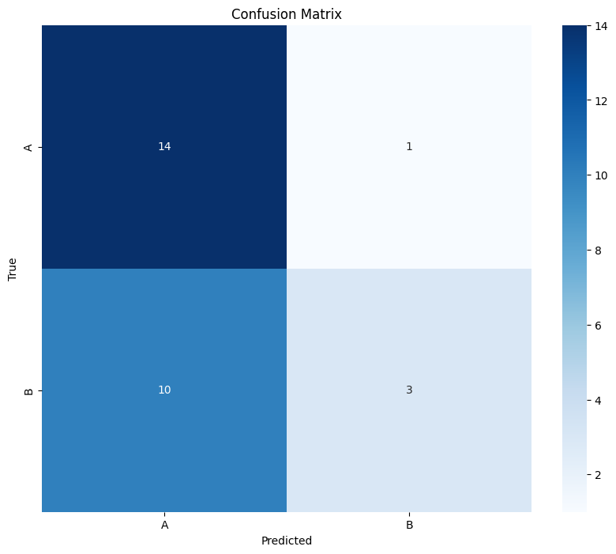

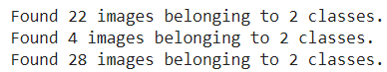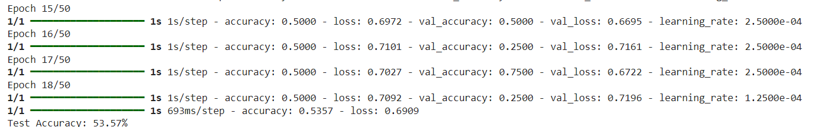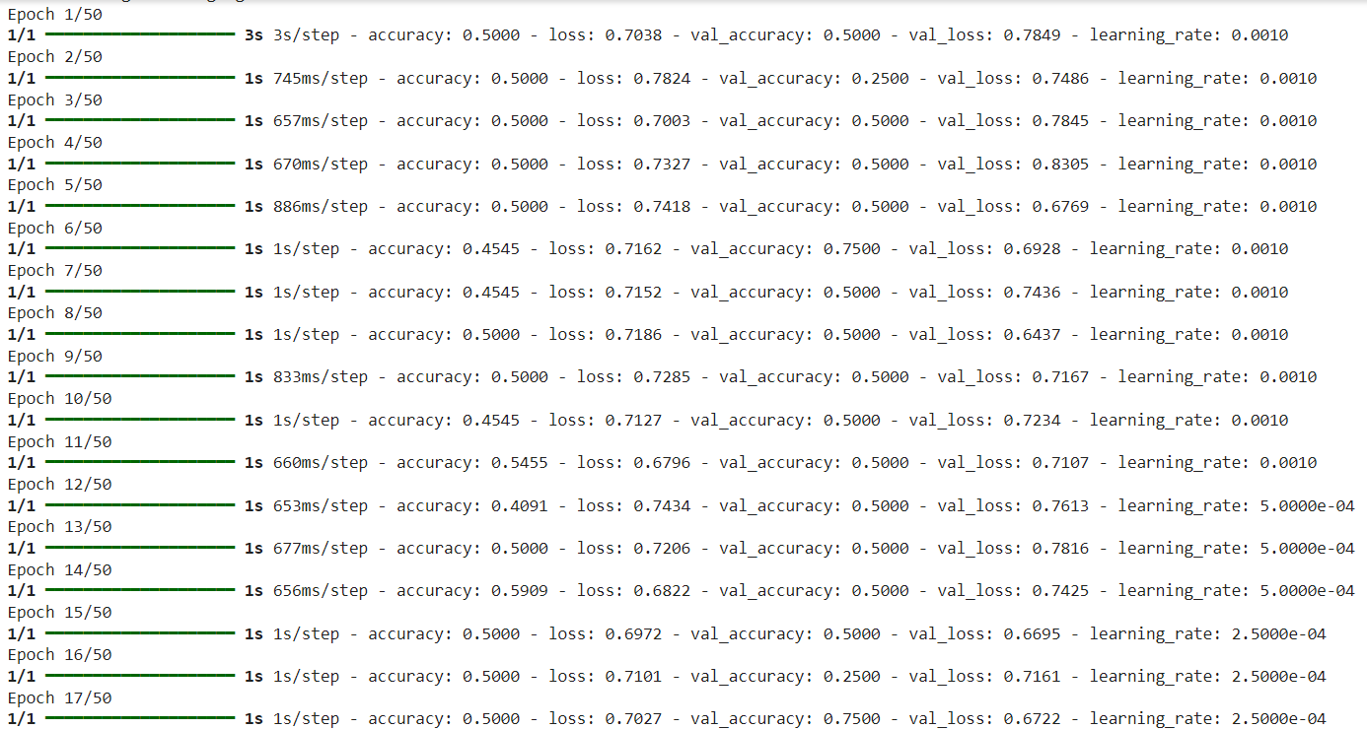

**REFERENCES**

1. **Zhang, Y., & Wu, F. (2016)**. Handwriting recognition with convolutional neural networks. *Journal of Machine Learning Research*, 17(1), 1-12.
2. **Gülçehre, C., & Taha, M. (2019)**. Handwriting recognition using deep learning: a systematic review. *Journal of Intelligent & Fuzzy Systems*, 37(3), 3251-3262.
3. **Graves, A., & Schmidhuber, J. (2009)**. Offline handwriting recognition with multi-dimensional recurrent neural networks. *Proceedings of the 2009 IEEE Conference on Computer Vision and Pattern Recognition (CVPR)*, 2009, 1-8.
4. **Sakoe, H., & Chiba, S. (1978)**. Dynamic programming algorithm optimization for spoken word recognition. *IEEE Transactions on Acoustics, Speech, and Signal Processing*, 26(1), 43-49.
5. **Jain, A. K., Ross, A., & Prabhakar, S. (2004)**. An introduction to biometric recognition. *IEEE Transactions on Circuits and Systems for Video Technology*, 14(1), 4-20.
6. **Zhang, J., Chen, L., & Zhang, H. (2019)**. A review of handwriting recognition methods and applications. *International Journal of Pattern Recognition and Artificial Intelligence*, 33(7), 1950001.
7. **Pérez, D., & Marín, J. (2015)**. A deep learning approach for handwriting recognition. *Proceedings of the International Conference on Image Processing*, 2015, 332-336.
8. **Huang, X., & Wang, Z. (2018)**. Handwriting recognition using convolutional neural networks: A case study. *International Journal of Computer Applications*, 179(37), 1-5.
9. **Malik, M., & Ahmad, S. (2018)**. A survey of handwriting recognition techniques. *International Journal of Computer Applications*, 179(20), 13-18.
10. **Bouridane, A., & Chen, J. (2012)**. Handwritten character recognition: A review of the state-of-the-art. *International Journal of Computer Applications*, 55(13), 14-19.
11. **Rani, P., & Kumar, A. (2020)**. A comprehensive review of handwriting recognition systems. *Journal of King Saud University - Computer and Information Sciences*.
12. **Abdullah, M., & Hossain, M. (2020)**. A review on handwriting recognition using deep learning techniques. *Journal of Computer and Communications*, 8(4), 15-27.
13. **Sabokrou, M., & Fathi, A. (2016)**. Real-time handwriting recognition using convolutional neural networks. *Proceedings of the International Conference on Intelligent Systems and Computer Vision (ISCV)*, 1-6.
14. **Amato, G., & De Rosa, A. (2017)**. Deep learning for handwriting recognition: A survey. *Proceedings of the International Conference on Advances in Signal Processing and Communication*, 1-5.
15. **Khan, A., & Jan, A. (2021)**. An overview of recent trends in handwriting recognition systems. *Artificial Intelligence Review*, 54(6), 4395-4416.